Name:_____________________________________________Date:______________Block:__________
Biology: Study Guide for Quarterly 1
Define the following terms:
- Evolution(Ex):
- Adaptation (Ex):
- Artificial selection(Ex):
- Extinction:
- Anatomy(Ex):
- Natural selection(Ex):
- Homologous structures(Ex):
- Independent variable:
- Heredity:
Answer the following:
- What do rival theories often encourage scientists to do?
- Why is it important for a researcher to communicate their results to others?
- What should an experimental research plan include?
- If you conducted an experiment and your data did not support your hypothesis, what should you do next?

- If a farmer choose to breed only those tomato plants that produce the most tomatoes, the farmer would be following what principle?

- Describe the major concept of Lamarck’s evolutionary hypothesis?
- What is the main concept of Darwin’s theory of natural selection?
- Why would extinction of a species occur?
- How did Darwin explain that only a small number of offspring survive to reproduce?
- Give an example of a rapid biological adaptation that has occurred.

- What might a biochemist use to compare organisms?
- In which classification category are organisms most similar?
- What is the scientific name made up of?
- What are characteristics that are unique only to humans?
- What information can the fossil record tell us?
- Scientists usually being their work by?
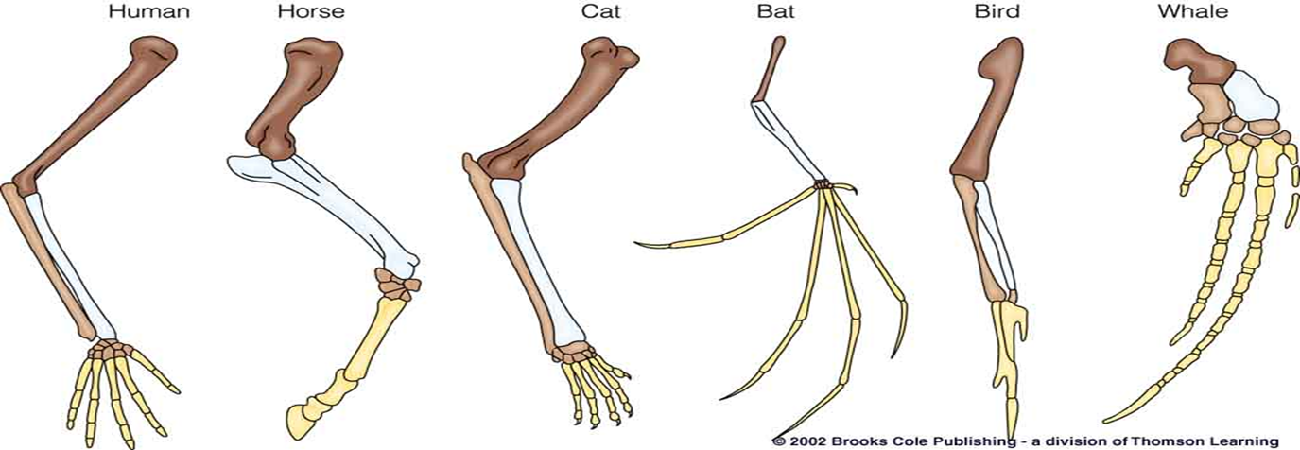
- What do the forelimb bones of the different organism above most likely indicate?

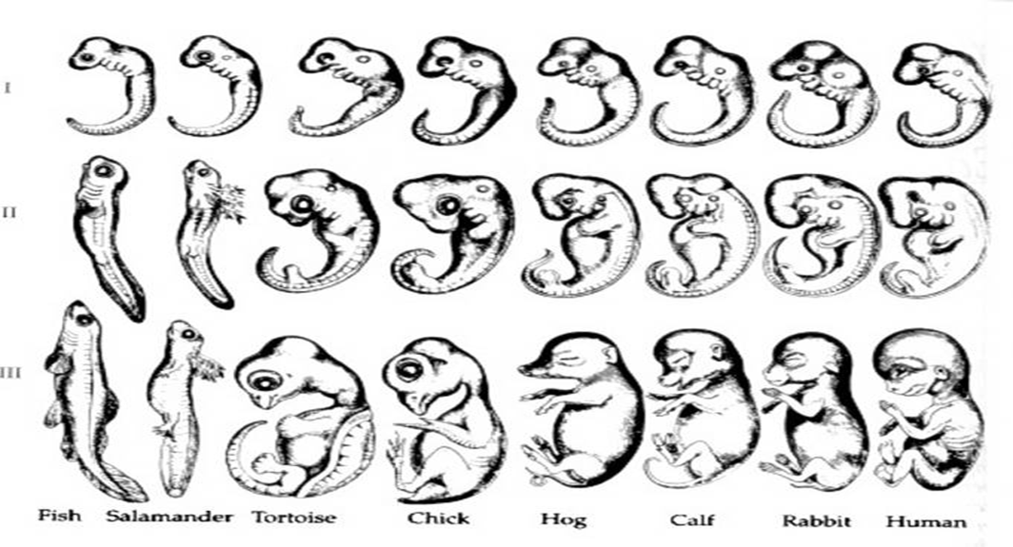
- The diagram above shows embryos of different species. Explain why it is thought that they provide proof of evolution?

*Be able to read and answer questions on a graph.
-Natural selection questions

