Name: _________________________________________ Period: ____________ Date: _________________
Modern Life: Evidence for Evolutionary Change Text page 107
Modern Life: Evidence for Evolutionary Change: Text page 107

Homology: Vestigial Structures: DNA:
Stands for:
____________________________
Define: _____________________ __________________________________________________________________________________________________________________
Define:__________________________________________________________________________________________________________________________________________________________________________________________________________________________
Define: _____________________ ___________________________________________________________________________________________________________________________________________________________________________________________________________

The method of storing information-including the code used to interpret it-is the same in all organisms.

Examples include: Examples include:
% of DNA same as human DNA:
Monkey: ______
Gibbon: _______
Chimp: ________

_________________________ _____________________________
_________________________ _____________________________
_________________________ _____________________________
_________________________ _____________________________
The genetic code is inherited from a
__________________ __________________
_________________________
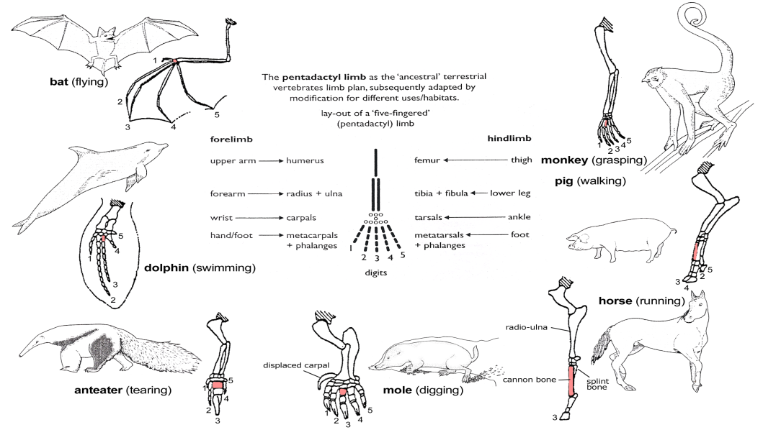
Examples of Homologous Structures
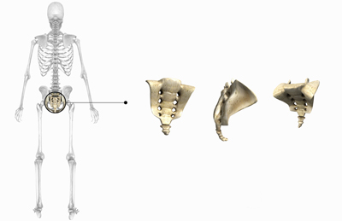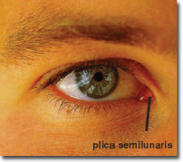
Examples of human vestigial structures:
The remnants of a human tailbone.
The remnants of our third eyelid-“nictitating” membrane.

