Name Block
Date Group
Essay: Phenotype and Genotype (p. 492-494)
(NEW VOCABULARY IS IN BOLD FACED PRINT)
- Read the essay from beginning to end-JUST READ IT!
- Complete the chart below.
 | Definition | Examples
Phenotype
Genotype

- Look at Figure E11.1 and read the description. Then read the second paragraph on p. 492. How did the environment in this example affect phenotype?

- Put the following terms in the boxes in order from smallest to largest. Then write the definition under each box. (gene, chromosome, DNA)

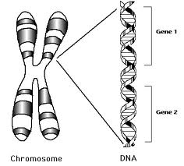
Label using the terms: gene, chromosome, DNA

- Examine Figure E11.3 and answer the following questions from the description and the essay.
  - What is an allele?
  - How many alleles are generally inherited for each phenotype (trait)?
  - Why does this number make sense?
  - Define
    - Homozygous
    - Heterozygous
  - Fill in the chart based on the diagram.
Phenotypes for Human Blood
Alleles | Blood Type | Heterozygous or Homozygous
(left side)
(right side)

- Complete the chart below
Phenotype | Definition | Example | Heterozygous or Homozygous
Dominant
Recessive

- What is INDPENDENT ASSORTMENT?

