Define stratigrahy: ______________________________________________________________________________
Explain how it is used to date fossils:
_____________________________________________________________________________________________________________________
How is this done? ______________________________________________________________________________________________________________________________________________________________________________________________________________________________________________________________________________________________________
List 3 kinds of radioactive isotopes in the circles below:
Technologies That Strengthen Fossil Evidence
Text page 104

Indirect Dating: Direct Dating:
Kind of rock where fossils are often found:

_____________
_____________

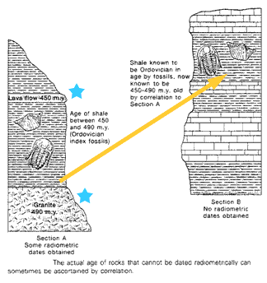
A
B
The oldest fossil found is ______________ _________ ________ BYA
Then came microorganisms, ancestral plants, invertebrates.
Fish ______________ MYA
Amphibians _________MYA
Dinosaurs _________ MYA
Mammals __________MYA
Birds _____________ MYA
Flowering plants ________ MYA
Lucy ________________ MYA

Which layer is oldest? ____________
Which layer is most recent? ___________

